## línea horizontal

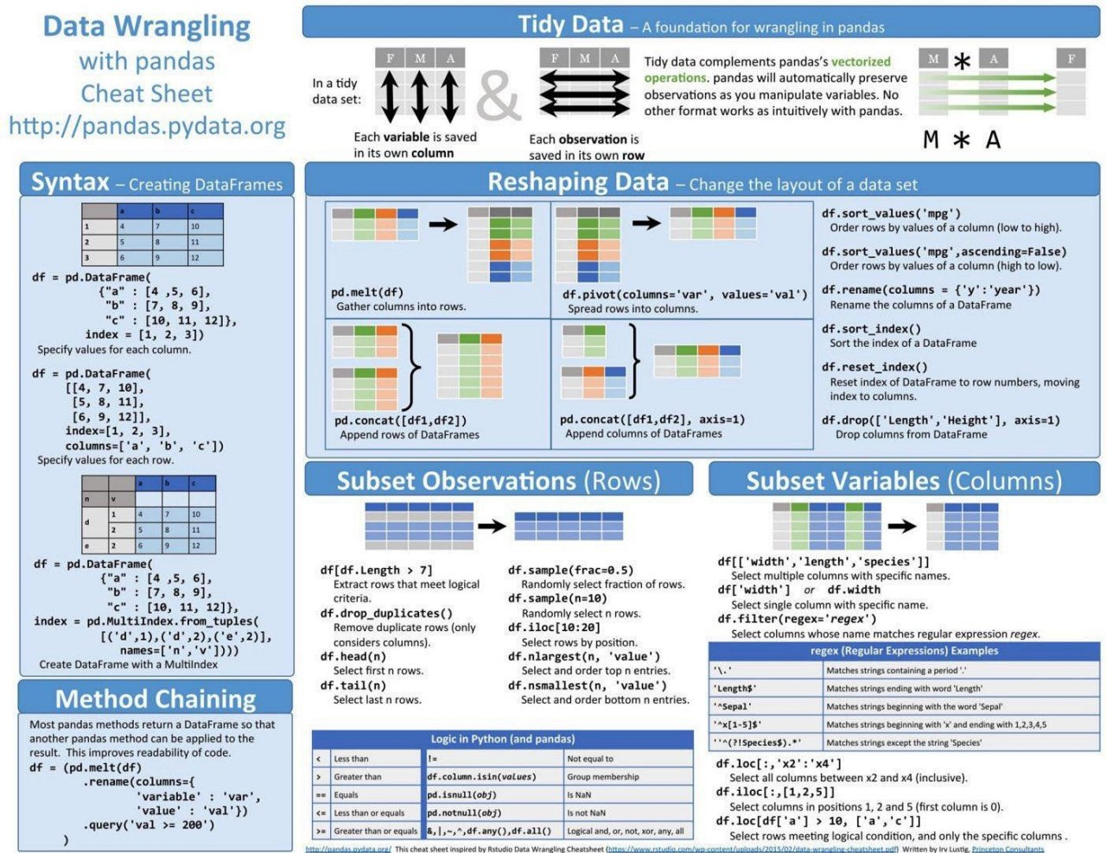

Group Delivery

23/07/2020 to 31/08/2020

**─**

Group A

Natalio Altube, Tomas Lizarazo, Rosario Marianeschi, Elsa Toribio.

Data Science

The Bridge

# General Vision

Our vision is to work and …… by using the tools learnt during the fisrt 7 weeks of DataScience BootCamp.

# Goals

Write here your evaluation goal. If you opt for option B, write B. If you opt for option A+, write all the pluses finished.

Visualize the data obtained, and practice

# Specifications

To achieve the goals and make the most out of the delivery, below you can see the detailed specifications.

## Software

Minimal Software needed for execution is MacBook Air – iOS Mac HD, OS X, 10.10.5

Platforms:

VS Code has been tested on the following platforms:

* OS X Yosemite
* Windows 7 (with .NET Framework 4.5.2), 8.0, 8.1 and 10 (32-bit and 64-bit)
* Linux (Debian): Ubuntu Desktop 14.04, Debian 7
* Linux (Red Hat): Red Hat Enterprise Linux 7, CentOS 7, Fedora 23

## Hardware

Minimal hardware needed for visualizing this work:

Visual Studio Code is a small download (< 100 MB) and has a disk footprint of 200 MB. VS Code is lightweight and should easily run on today's hardware.

It is recommended:

* 1.6 GHz or faster processor
* 1 GB of RAM

## Requirements

Visual Studio Code

Additional Windows requirements:

Microsoft .NET Framework 4.5.2 is required for VS Code. If you are using Windows 7, please make sure [.NET Framework 4.5.2](https://www.microsoft.com/download/details.aspx?id=42643" \t "_blank) is installed.

Additional Linux requirements:

* GLIBCXX version 3.4.15 or later
* GLIBC version 2.15 or later

Python 3.6 – Libraries to import: matplotlib, pandas, seaborn, plotly.express, plotly.graph\_objects as go, plotly.figure\_factory as ff, from plotly.colors import n\_colors, from plotly.subplots import make\_subplots, nbconvert, nbformat, %matplotlib inline, plot as pltt and pycountry.

# Steps

## Research the context

There is plenty of information about COVID19 nowadays. The majority of the Search engines will show COVID19 on the top places of the ranking, as well as the main headlines in the news.

In summary, COVID-19 is the infectious disease caused by the most recently discovered coronavirus. This new virus and disease were unknown before the outbreak began in Wuhan, China, in December 2019. COVID-19 is now a pandemic affecting many countries globally. In most cases, COVID-19 causes mild symptoms including dry cough, tiredness and fever, though fever may not be a symptom for some older people. Other mild symptoms include aches and pains, nasal congestion, runny nose, sore throat or diarrhoea. Some people become infected but don't develop any symptoms and don't feel unwell. Most people recover from the disease without needing special treatment. Around 1 out of every 6 people who gets COVID-19 becomes seriously ill and has difficulty breathing.[[1]](#footnote-1)

For this particular assignment, we used information found on the website selected by the school program. Our group was designated to show the new COVID19 cases detected in Argentina, Chile, Colombia, Russia and Spain since January 2020 to present.

## Get Data

The url we used to get the data from, is the following:

<https://ourworldindata.org/coronavirus-source-data>

## Data Wrangling

We selected the file that is in .csv format and always up-to-date, to import it in Python and turn it into a dataframe. As it had the information about all the countries, and all the categories (such as: total deaths per million, new cases per million, new tests, population, median age, gdp per capita, poverty index, etc..) we arranged it in order to obtain the information we needed.

## Data Mining / Clean Data

Your text...

## Others...

As part of the activity, we created a flask server file, to build an API and enable the other work group to get the necessary information from us. That’s how they could access our .json file.

Hence, we converted the file containing the mean of new cases detected in the 5 countries we were assigned into a .json. We made the dictionary (.json) available for the other group on the screen of the API. So they accessed through our IP, endpoint and entered our token code.

1. <https://www.who.int/emergencies/diseases/novel-coronavirus-2019/coronavirus-disease-answers?query=history+of+covid+19> [↑](#footnote-ref-1)